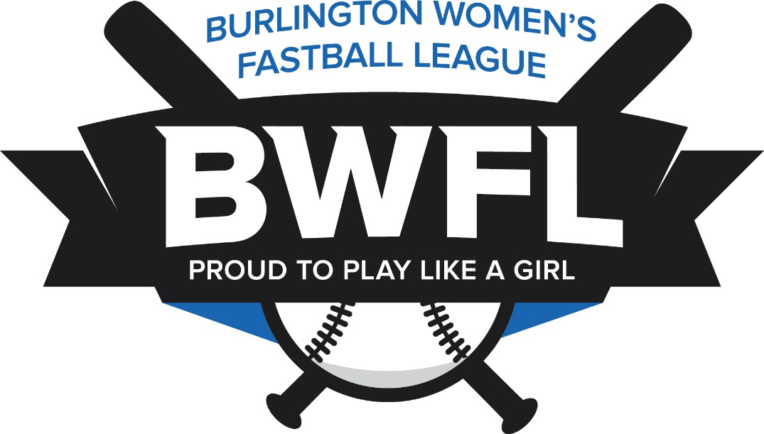
Member Code of Conduct for the BWFL
It is the objective of the Burlington Women's Fastball League (BWFL) to provide an environment for its players that is void of verbal or physical abuse/harassment. It is not only requested, but required, that all members are respectful of other members of our league and behave in a manner, at all times, which is a positive reflection on the BWFL.
In order to ensure that our members live up to this measure, please notify your team rep or a member of the Executive Board of any situation that occurs where you feel you are the recipient of intentional malicious abuse or extremely poor sportsmanship. It is part of the team rep's responsibility to bring such claims to the attention of the Executive Council.
If requested, a meeting will be held with the Executive and all involved parties. After an impartial review of the facts, a vote of the Executive Council will take place. If any member(s) of the Executive are directly involved in the situation, they will be excluded from the vote (as long as a minimum of four Executive members remain to cast votes).
Any member who has been found to exhibit inappropriate behaviour can expect corrective action and possible dismissal from the league, with no monetary compensation

